CS 3451 Project 10

Name: Shen Yang

CS 3451 Project 10 Shading

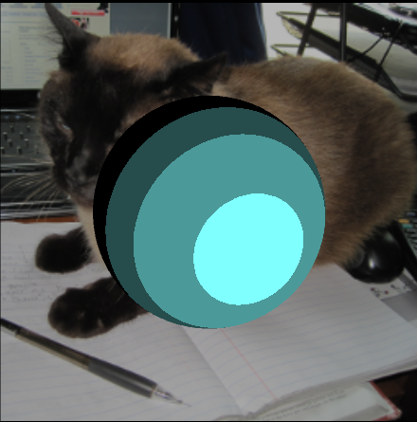Fragment 1: (Press 1)

Vertex 3: (Press 2) Fragment 4: (Press 3)

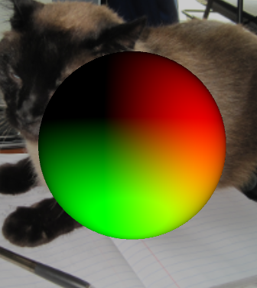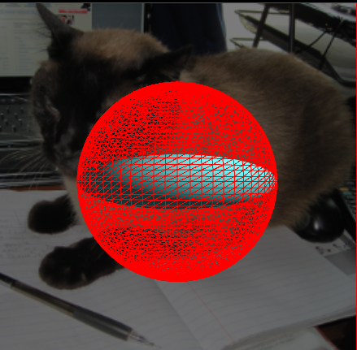

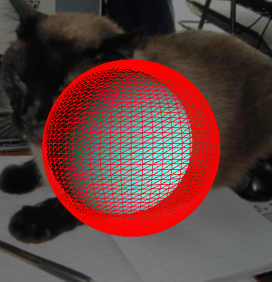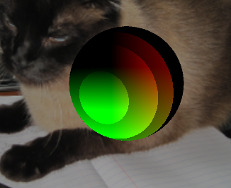Vertes 4: (Press 4) Extra Credit: (Combining all except vertex 3) (Press 5)

Using fragment/vertex shaders utilize the GPU which is much faster than using normal programming language (CPU).